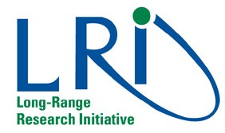

LRI Innovative Science Award 2016
Are you a rebel thinker? Do you have a good idea?
Make it come alive!
Are you a promising early-career scientist? Do you have an innovative idea?

The European Chemical Industry Council (Cefic) in conjunction with SETAC, EUROTOX, ISES and the Chemical Week is offering a €100.000 award to support promising new research in the field of novel approaches to the characterisation of molecular initiating events, or other key events, in pathways of human and environmental toxicity
LRI Innovative Science Award 2016

The award is intended for a European-based scientist with less than ten years post-doctoral experience
Deadline for applications: 18 March 2016

For terms, conditions and guidelines go to:
http://cefic-lri.org/funding-opportunities/apply-for-the-lri-award/
LRI Award Ceremony:
6 June, 2016
Sheraton Brussels City Centre

.

www.cefic-lri.org

