CEFIC Long-range Research Initiative
Request for Proposals (RfP)

Title and Code Number:
A regulatory modelling tool for predicting nano and micro-plastics additives concentrations (PEC) in the environment and biota / LRI-ECO58

Background
Nano- (< 1µm) and microplastics (< 5000 µm) are of increasing concerns for both human health and the environment worldwide. Many of those plastics include chemical additives either coated at the polymer surface or entrapped in the polymeric matrix. These additives can either be of solid or molecular nature. One concern amongst many is the leachability of these additives into both the environment (potential for general release) and the digestive tract (potential for bioaccessibility). Bioaccessibility is here defined as the quantity of a compound that is released from its matrix in the gastrointestinal tract, becoming available for uptake (Galanakis, 2017). Since uptake in an organism’s body (epithelium or membrane crossing) solely depends on the intrinsic property of the additive, regardless of their leachability, uptake is out of the scope of the project. It is assumed that the main factors driving leachability are among others: (i) the intrinsic properties of the polymeric matrix, including alteration of the matrix in its surrounding environment (including digestive tract), (ii) the intrinsic properties of the additives, (iii) the manufacturing process (coating vs entrapment), (iv) the conditions of the receiving system (static vs. dynamic) and other extrinsic factors (e.g. temperature, medium, natural occurring organic matter, suspended solids, fugacity, etc), (v) the interactions between the main factors, and so on. It is however expected from the applicant to bring its expertise around those aspects.

Objectives
The overarching goal of the project is to develop a generic modelling tool for exposure and risk assessment, recognized and applicable by the scientific community and potential regulators and that can predict (1) environmentally relevant leaching potential and (2) - based on input from Cefic LRI ECO57 on the presence and other relevant properties of MNP in the compartment or biota – predicted environmental concentration of the leached additive. The tool should be parametrizable to account for the various conditions and main driving factors for leaching. This modelling tool should be conceived so that it is easily includable in a broader modelling tool, Cefic LRI ECO56, which focusses on the development of a generic multi-media fate model of microplastics which aims at predicting the environmental concentration of nano- and microplastics in the environment. Both projects will be run in parallel.
The project’s objectives are to :
1. Conduct a literature search to identify the driving factors of additive (both solid and molecular) leachability in the aquatic environment and the digestive tracts of various organisms. Review of representative digestive tract should be included: species, residence time in the gut, gut conditions, etc. The search should also identify existing approaches for generic modelling of additive leaching.
2. Conceive a modelling tool for risk assessment that predicts environmentally relevant leaching potential (i) in all environmental compartments and (ii) the digestive tracts of various relevant organisms (soil/sediment dwellers, fish, bird, human…). For the sake of time, the chosen model(s) shall build on already available approaches and models (see objective 1). The development of a new model is also acceptable if, from the expertise of the applicant, no existing model suits the purpose of the present project. The model needs to be generic and applicable to all type of combination of the above-mentioned main factors driving leaching.
3. Dependent on objective 1, conduct laboratory experiments to determine parameters needed to build the model. This is of particular interest for the environmentally relevance of the model (e.g. aging of the material and dependent altered matrix properties).
4. Ensure interconnectivity to the general generic multi-media fate model by Cefic ECO56. Therefore, the generic leaching model should include an input option to combine with data on presences as well as relevant properties of MNP in the environment (Cefic LRi ECO57) to derive environmentally relevant concentrations of additives (PECs) in both the environment and as well as “sediment/soil dwelling organisms”/fish/bird digestive tracts as a function of exposure to nano- and microplastics.
5. Ensure validity of the model to achieve acceptance in regulatory processes.

This graphic illustrates the connectivity to Cefic LRI ECO57:

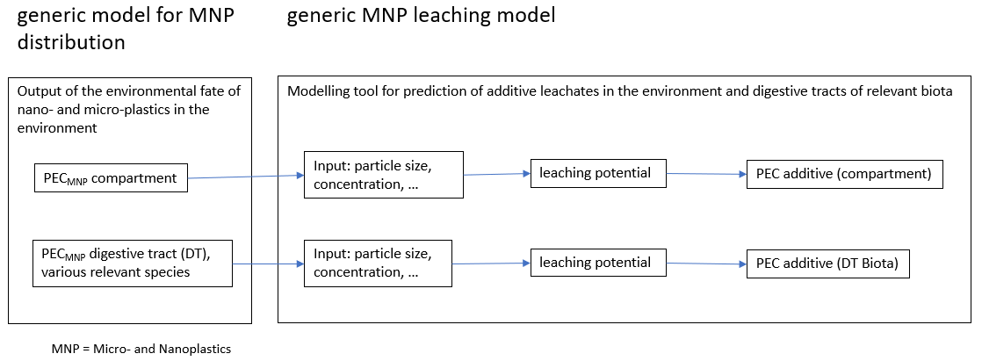

Scope
The project aims at modelling generically the leachability of solid and molecular additives in the environment and the digestive tracts of relevant organisms susceptible to microplastics exposure via ingestion. This includes applicability to various types of nano- and microplastics (structure, size, chemistry…) and additive chemistries. Based on input data on environmental concentration of MNP, the model should derive predicted environmental concentrations (PECs) of potentially included additives. The model should allow to compare those PECs to their respective PNECs.

Deliverables
- A report on the results of the literature search to identify the factors that drive solid and molecular additive leachability. Review of representative digestive tract should be included: species, residence time in the gut, gut conditions, etc. The report should also contain an overview on the search on available models that suit the aim of the present project.
- A generic modelling tool that predicts environmentally relevant leaching potential of solid and molecular MNP additives in relevant environmental compartments and digestive tracts of relevant biota. The modelling tool should be capable of input on MNP concentration in the respective compartment to finally derive predicted environmental concentrations of leached additives. The tool should be robustly validated so that it can be used for regulatory purpose. Validation shall be based on already available data (literature search). This may be completed with the conduction of appropriate experiments if needed.
- Semi-annual reports informing the sponsor about the progress and achievements of the projects with regards to the objectives, work packages, deliverables and schedule.
- A final report that shall contain an executive summary (2 pages max), a main part (max. 50 pages) and a detailed bibliography. It is expected that the findings will be developed into at least one peer reviewed publication, following poster(s) and presentation(s) at suitable scientific conference(s). The model should be provided open-source and include a documentation.

Cost and Timing
Start in xxx, duration 2 years
Budget in the order of € 350K

Partnering / Co-funding
Applicants should provide an indication of additional partners and funding opportunities that can be appropriately leveraged as part of their proposal. Partners can include, but are not limited to industry, government/regulatory organizations, research institutes, etc. Statements from potential partners should be included in the proposal package.

Fit with LRI objectives / Possible regulatory and policy impact involvements / Dissemination
Applicants should provide information on the fit of their proposal with LRI objectives and an indication on how and where they could play a role in the regulatory and policy areas. Dissemination plans should also be laid down.

References
Galanakis C., 2017. What is the Difference Between Bioavailability Bioaccessibility and Bioactivity of Food Components? Food Science and Nutrition http://scitechconnect.elsevier.com/bioavailability-bioaccessibility-bioactivity-food-components/

DEADLINE FOR SUBMISSIONS: June 30th 2021
Please see www.cefic-lri.org/funding-opportunities/apply-for-a-grant/ for general LRI objectives information, project proposal form and further guidance for grant applications.

